Task-Based Activity: Interpret a hockey schedule
Laubach Connection: Laubach Way to Reading (LWR) Book 3, Lesson 10
OALCF Link
Relevant Goal Paths
Apprenticeship, Employment, Independence, Postsecondary, Secondary School Credit
Rationale: Learners on all the goal paths will need to interpret schedules for a variety of different reasons.

Task-Based Activity Description: The learner will interpret two hockey schedules to determine game times.
Competency, Task Group and Level Indicators
(See Assessment page for performance descriptors)
A: Find and Use Information
A2: Interpret documents
- A2.2 Interpret simple documents to locate and connect information

C: Understand and Use Numbers
C2: Manage time
- C2.1 Measure time and make simple comparisons and calculations

Materials Required
- Pen or pencil and eraser
- Question sheets

Overview
Activity Introduction
This task uses two television hockey game schedules.

Lesson 10 is about Pete. Pete owns a repair shop but as a young man he played hockey. Discuss with the learner if they have ever played hockey or like to watch hockey. Discuss the fact that hockey is considered a national pastime in Canada. Ask the learner if they ever had trouble reading schedules. Discuss the fact that schedules come in a variety of different formats.

New words
Determine any new words that you think are being introduced in the activity and review those words with the learner.

Instructions
- Have the learner fill in their name and the date.
- Have the learner complete the pre self-assessment.
- Have the learner complete the task-based activity.
- After completing the activity, have the learner complete the post self-assessment.
- After the learner has completed the task-based activity, complete the assessment section and review the results with the learner.

Extension activities
- Interpret online television listings

Task-Based Activity: Interpret a hockey schedule

Learner Name: _____________________________ Date: ____________________________

Pre self-assessment

I need to improve my skills at:
- Yes
- No

Activity
Sunday, April 13
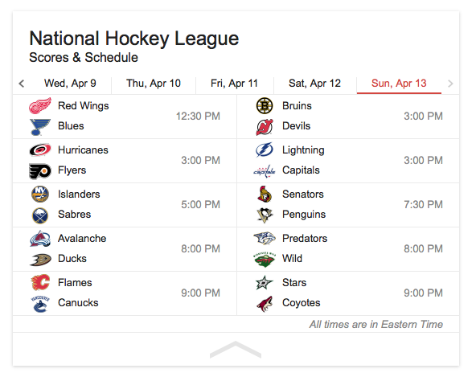

- What time are the Flames playing? __________________________________________

- What day and time are the Flyers playing? ____________________________________

- What team is playing against the Bruins on Sunday April 13th? ____________________

- If you want to watch the Penguins v. the Senators, what time do you need to turn your television on? ___________________________________________________________

- How many different games are there on Sunday April 13th? _______________________

- If you only watched the first ½ hour of as many games as possible on Sunday, April 13th, what is the maximum number of part games you could watch? ____________________

Post self-assessment

I think my skills have improved as a result of completing this activity.
- Yes
- No

Learner comments:
______________________________________________________________________________
______________________________________________________________________________
______________________________________________________________________________

Assessment
Task-Based Activity: Interpret a hockey schedule
Learner Name: ______________________________ Date: ____________________________

Practitioner Name: _______________________________________

Performance Descriptors | Needs Work | Improving | Excellent
A2.2: Interpret simple documents to locate and connect information
- performs limited searches using one or two search criteria
- extracts information from tables and forms
- uses layout to locate information
- makes connections between parts of documents
- makes low-level inferences
- begins to identify sources and evaluate information

C2.1: Measure time and make simple calculations
- adds, subtracts, multiplies and divides whole numbers and decimals
- recognizes values in number and word format
- identifies and performs required operation
- represents dates and times using standard conventions
- interprets and represents time using whole numbers, decimals (e.g. .25, .5) and simple common fractions (e.g. ½, ¼ hour)
- follows apparent steps to reach solutions

The learner needs to work on the following:

This task was successfully completed ______ This task needs to be tried again ______

Practitioner Comments:

Learner Comments:

